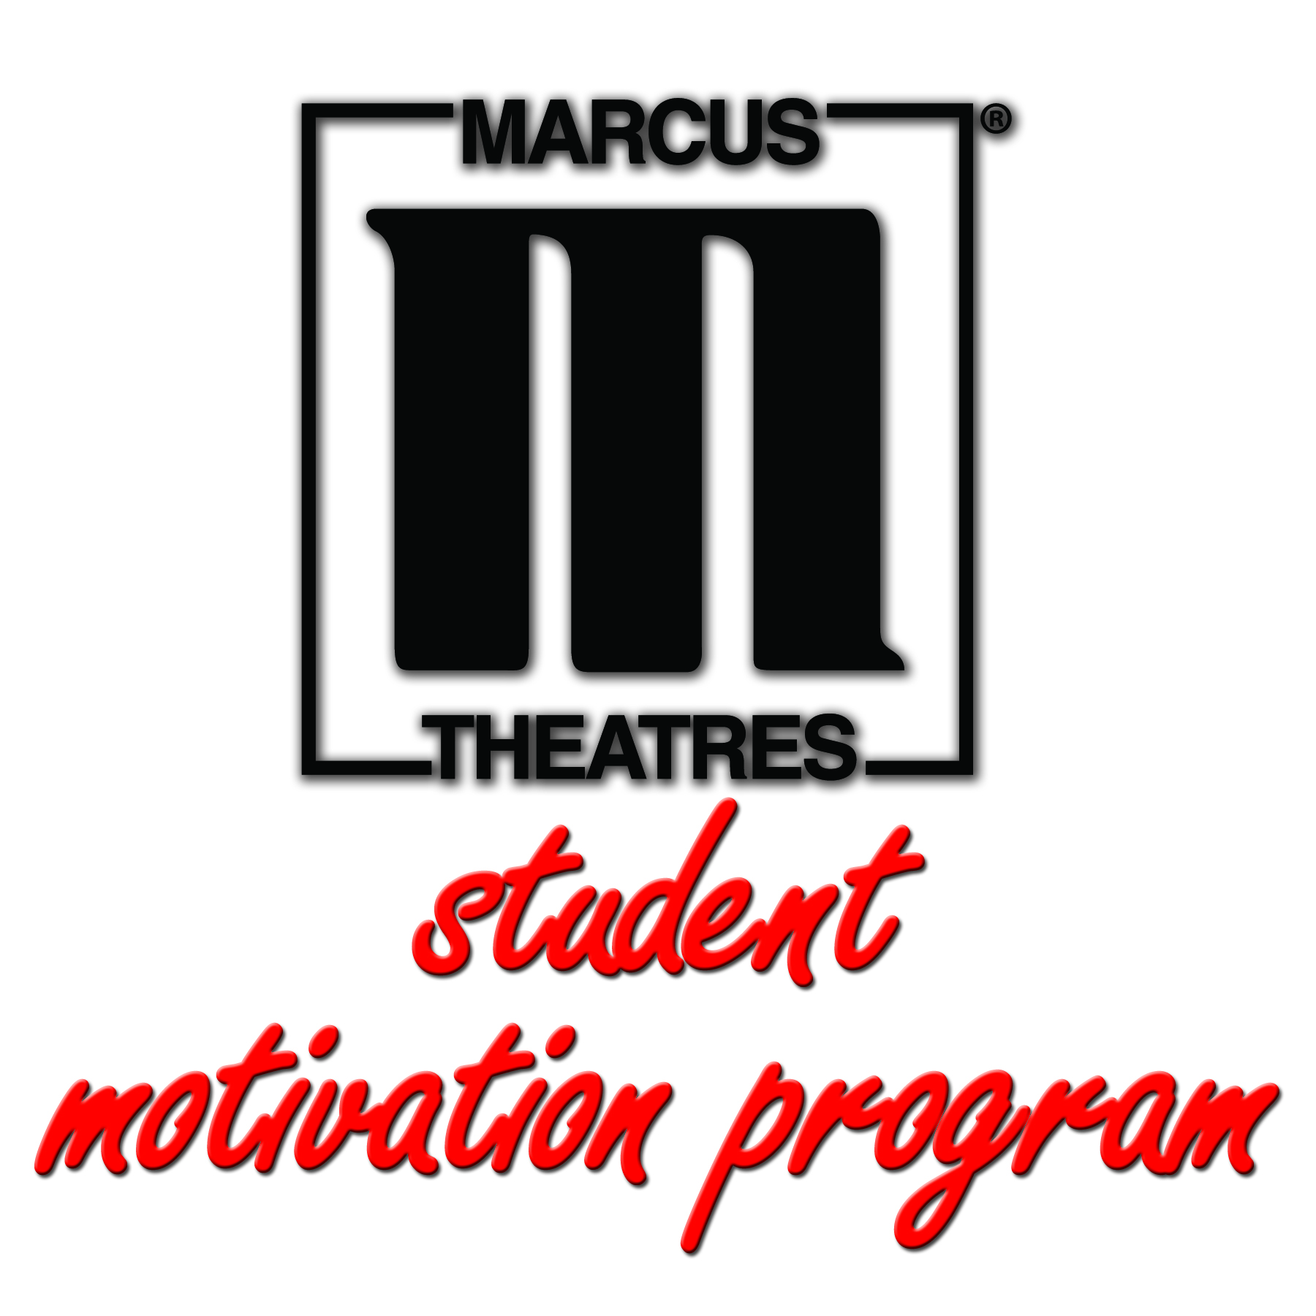

Thank you for enrolling your district or school in Marcus Theatres’ 2017-18 Student Motivation Program. As part of this partnership, we ask that you please complete at least two of the items listed below during this school year to help create awareness of the program.

These materials are also available online at MarcusTheatres.com/SchoolInfo

- Flyers – Hang 8.5x11 program flyers in hallways, classrooms or other common areas.

(Visit the link above to download the flyer and print the quantity that fits your needs.)

- Take-home folder or envelope stuffer – Enclose a brief communication from Marcus Theatres in take-home information (i.e. notes, report cards, etc.).

(Visit the link above to download the folder/envelope stuffer and print the quantity that fits your needs.)

- Newsletters – Mention the program in a school newsletter or email communication using sample text (see below) from Marcus Theatres.

- Social media – Mention on social media using sample text (below) from Marcus Theatres.

- Website – Using sample text (below), post an announcement on your school’s website.

Sample Text: Newsletter

Headline: Movie vouchers for academic achievers!
Body: Good grades, perfect attendance, being a role model and other achievements at school just got more rewarding. This school year, students who go above and beyond in their activities in and outside of class will be eligible to earn a voucher for movie tickets. As part of Marcus Theatres’ Student Motivation Program, each voucher is good for buy-one-get-one admission at the box office at any Marcus Theatres location. [NAME OF SCHOOL] will recognize student achievers throughout the school year. See a faculty member for more details.

Sample Text: Social Media

Get rewarded for being a great student! Did you know that [NAME OF SCHOOL] offers tickets to the movies for being a higher achiever? Keep your grades up, participate in school activities and be a role model for your peers – and you could earn a voucher for a FREE movie at Marcus Theatres!

Sample Text: Website

Headline: Achieve big and earn a free trip to the movies!
Body: To encourage academic achievement, good reading habits, perfect attendance and positive connections within the school and community, [NAME OF SCHOOL] is a partner of Marcus Theatres’ Student Motivation Program. This school year, students who go above and beyond in their activities in and outside of class will be eligible to earn a voucher good for buy-one-get-one admission at the box office at any Marcus Theatres location. See a faculty member for more details.

